PE Definition

Description: A highly efficient, instruction-set driven Processing Element (PE) for accelerating quantized neural network inference.

PE Operation

The PE operates as an instruction-driven hardware accelerator designed to offload computationally intensive neural network inference tasks. Controlled by a Chip Select signal, the PE transitions between a no-operation state and an active execution mode. The PE operates on quantized signed integers, which serve as efficient approximations of the original floating-point number model parameters. When enabled and valid, the internal controller samples the operational code and the input data buses, causing activity in the following clock cycle.

Following the input validity signal, two registers ingest signed 32-bit packed integer operands, typically representing neural network inputs and weights. The PE can dynamically reconfigure its arithmetic core to support high-fidelity INT8 operations or high-throughput INT4 operations, selected by a pre-loaded configuration register. It also supports a multi-cycle uint-by-int scalar multiplication for rescaling.

The computational datapath executes operations sequentially. It first performs a series of Multiply and Accumulate (MAC) operations to collect partial sums, adds a bias value, then applies the uint-by-int multiplication to finalize the arithmetic phase into the 64-bit register. Once all math operations are complete, the massive 64-bit signed accumulator is shifted and saturated down to a 4/8-bit signed integer. A hardware-based activation function, selected by the same configuration register, then processes this scaled value to finalize the inference result. This final activation output is driven to the output bus, which is synchronized with an output_valid signal to ensure seamless and accurate integration with the host system.

The power-up state of the PE is undefined. For a known initial state, the user must assert the active-low asynchronous reset, which clears all internal registers and initializes the datapath to a default idle state with a zeroed accumulator. Upon release of reset, pe_ready rises immediately, indicating the PE is ready to accept its first instruction.

Instruction Set Architecture

Opcode Table

Opcode | Mnemonic | Full Name | Description
00000 | NOP | No Operation | System idle; all internal registers hold their current state.
00001 | RST_ACC | Reset Accumulator | Clears the 64-bit signed accumulator register to zero.
00010 | MAC | Multiply and Accumulate | PE treats the 32-bit inputs as packed signed integers in the precision mode selected by the configuration register.
00011 | ADD_BIAS | Add Bias | Adds the 32-bit bias to the accumulator from the operand_B bus.
00100 | SCALE | UInt-By-Int Multiplication | Multi-cycle scaling; multiplies the lower 32 bits of the accumulator by operand_B and overwrites the accumulator for scaling. Also loads the 6-bit shift-amount register from operand_A_reg[5:0] at cycle 0.
00101 | LOAD_CFG | Load Configuration | Loads the 4-bit PE configuration register from operand_A_reg[3:0].
00110 | EXEC_PP | Execute Post-Processing | Triggers the Post-Processing Unit (PPU) to requantize the 64-bit accumulator and apply the selected activation function.
00111 | READ_ACC_BYTE | Read Accumulator Byte | Routes one byte of the 64-bit accumulator, selected by operand_A_reg[2:0], to data_out.
01000 | READ_CFG | Read Configuration Register | Routes the configuration register value to data_out.
01001 - 11111 | RSV | Reserved | Reserved for future instruction expansion.
Table 1. Operational-Code.

Instructions Breakdown

- NOP: Enables Auto Clock Gating to minimize dynamic power. Since no registers are updated, the synthesis tool freezes the clock tree until a new command is issued.
- RST_ACC: This instruction clears the accumulator. No operands are required on the data buses for the execution of this instruction.
- MAC: Configures the datapath for the precision mode held in the PE configuration register. In INT8 mode, the 32-bit buses are interpreted as four packed, signed 8-bit integers. In INT4 mode, they are interpreted as eight packed, signed 4-bit integers. The products are computed in parallel and added to the accumulator.
- ADD_BIAS: The 32-bit value on the operand_B bus is added directly to the current 32-bit accumulator sum.
- SCALE: This instruction initiates a multi-cycle scaling operation. The hardware captures the lower 32 bits of the current 64-bit accumulator, and multiplies this internal value by an unsigned 32-bit scaling factor presented on operand_B. The final 64-bit product overwrites the previous accumulator state. The PE's FSM transitions out of its IDLE state, indicating that the PE is busy and cannot receive new instructions. Upon completion of the final cycle, the PE pulses the scale_done status flag for one clock cycle as the FSM transitions back to its IDLE state, signaling the host that it can assert the next instruction. Additionally, the lower 6 bits of operand_A are captured into the PPU's shift-amount register on the rising clock edge when SCALE is decoded. This couples the scaling factor with its requantization parameters in a single instruction presentation.

- LOAD_CFG: This instruction loads the 4-bit PE configuration register from operand_A[3:0] in a single clock cycle. Eight encodings select the activation function (Identity, ReLU, two Leaky ReLU variants, Tanh, Sigmoid, GELU, SiLU); two encodings select the arithmetic precision mode (INT8 or INT4). This instruction must be issued before computation begins for the current layer. See the Configuration Register section for the full encoding table.
- EXEC_PP: This instruction triggers the PPU. The unit reads the 64-bit accumulator, applies an arithmetic right-shift using the pre-loaded 6-bit shift amount, rounds it to the nearest integer, clamps the result to the signed 4/8-bit range, and passes it through the selected activation function. The final 4/8-bit result is routed to the output register.
- READ_ACC_BYTE: This instruction exists for testing and debug purposes. It routes a single byte of the 64-bit accumulator to data_out and pulses output_valid for one clock cycle. The byte is selected by operand_A[2:0] driving an 8:1 multiplexer: encoding 0 selects acc[7:0], encoding 1 selects acc[15:8], and so on up to encoding 7 which selects acc[63:56].
- READ_CFG: This instruction exists for testing and debug purposes. It routes the 4-bit configuration register to data_out, zero-padded to 8 bits, and pulses output_valid for one clock cycle.

I/O Interface

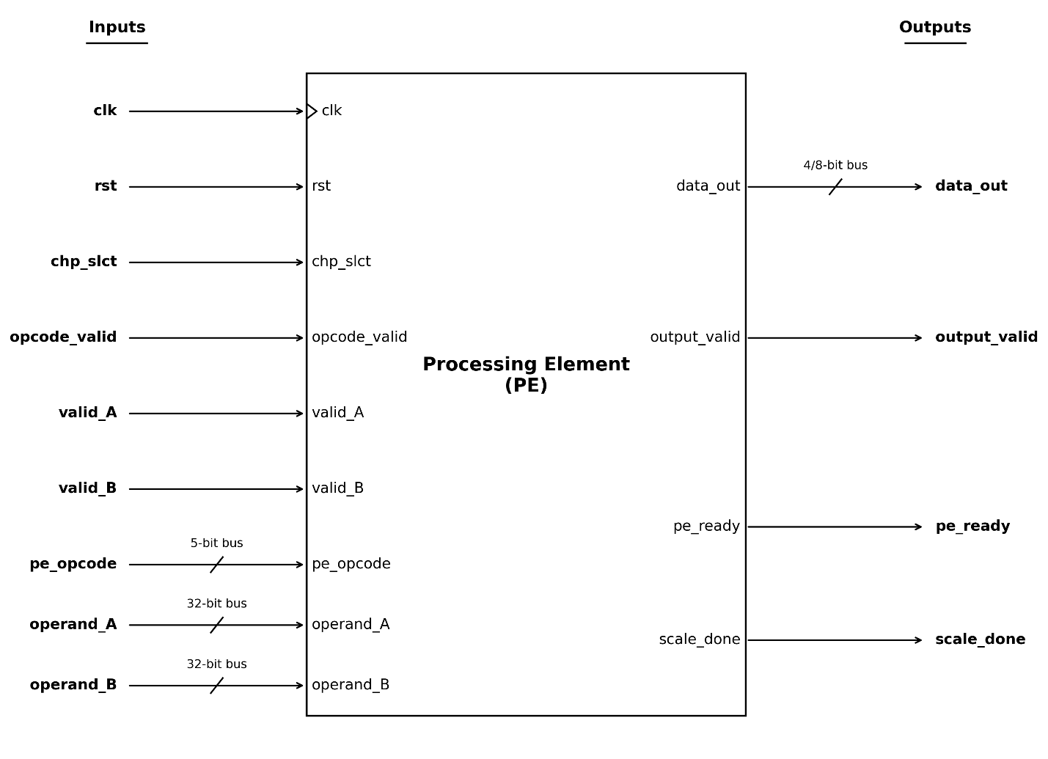
Figure 1. PE interface.

The following table defines the input and output ports of the Processing Element. All signals are sampled on the rising edge of the main system clock.

Signal Name | Signal Type | Width | Direction | Function | User Note
clk | Global | 1 bit | Input | System Clock | Main system clock.
rst | Global | 1 bit | Input | System Reset | Active-low asynchronous reset. Clears all internal registers to a defined state.
chp_slct | Control | 1 bit | Input | Chip Select | When inactive, new instructions and operands are not sampled. Instructions already captured into the internal opcode register continue to completion, as described in the Operand Sampling section.
valid_A | Control | 1 bit | Input | Operand A Validity | When high, the operand_A register captures the data on the operand_A bus. Independent of the opcode and operand_B validity signals.
valid_B | Control | 1 bit | Input | Operand B Validity | When high, the operand_B register captures the data on the operand_B bus. Independent of the opcode and operand_A validity signals.
opcode_valid | Control | 1 bit | Input | Operational Code Validity | When high, the opcode register captures the instruction on the pe_opcode bus. Independent of the operand validity signals.
operand_A | Data | 32-bit bus | Input | NN Inputs / Weights / Configuration | Packed integer data bus. Contains four signed INT8s or eight signed INT4s during MAC, a 6-bit shift amount on bits [5:0] during SCALE, a 4-bit configuration value on bits [3:0] during LOAD_CFG, or a 3-bit byte index on bits [2:0] during READ_ACC_BYTE.
operand_B | Data | 32-bit bus | Input | NN Inputs / Weights / Bias / Scaling Factor | Packed integer data bus. Contains four signed INT8s or eight signed INT4s during MAC, a 32-bit unsigned scaling factor during SCALE, or a 32-bit signed bias during ADD_BIAS.
pe_opcode | Control | 5-bit bus | Input | Operational Code | The instruction that needs to be executed.
data_out | Data | 8-bit bus | Output | NN Output | The final 4/8-bit quantized inference result following EXEC_PP, a single accumulator byte during READ_ACC_BYTE, or the zero-padded configuration register value during READ_CFG.
output_valid | Control | 1 bit | Output | Output Validity | Pulsed high for one clock cycle following an EXEC_PP, READ_ACC_BYTE, or READ_CFG instruction, indicating that the data on data_out is a valid result.
pe_ready | Control | 1 bit | Output | Ready Flag | Flow-control flag. When high, the PE is ready to accept new instructions. Driven low during multi-cycle operations (SCALE).
scale_done | Control | 1 bit | Output | Scale Completion Flag | Pulsed high for one clock cycle when the FSM returns to its IDLE state after completing a multi-cycle SCALE operation, signaling the host that it can assert the next instruction.
Table 2. I/O.

Operand Sampling and Data Routing

The PE contains two 32-bit operand registers at the top level (operand_A_reg, operand_B_reg) and several internal state registers inside the Controller and Requantizer. Data capture across these registers is decoupled into two independent mechanisms.

The two operand registers update on the rising clock edge when their respective validity signal (valid_A or valid_B) is high, qualified by pe_ready and chp_slct. These registers feed the MAC & SCALE datapath and are the primary datapath for computation instructions.

The internal state registers - the configuration register, the shift-amount register, and the byte-select path - are sourced from sub-fields of operand_A_reg. They capture when the Controller decodes their associated opcode (LOAD_CFG, SCALE, or READ_ACC_BYTE respectively). Because these registers read from operand_A_reg, the user must co-assert valid_A alongside the instruction so that operand_A_reg holds the intended value when the downstream capture occurs.

The chp_slct signal participates only in the capture gates of the opcode register and the two operand registers. Once an instruction is captured into the opcode register, all downstream decode and control-signal generation is derived entirely from registered internal state - the opcode register, the FSM state, and the configuration register - none of which depend on chp_slct. If chp_slct deasserts after an instruction has been captured, the capture gate forces NOP into the opcode register on the next edge, preventing any new instruction from entering, but the already-captured instruction completes normally. For single-cycle instructions, the effect is realized on the first rising edge after capture, before any new opcode could overwrite the register. For the multi-cycle SCALE, the FSM transitions unconditionally through its internal states regardless of chp_slct, and pe_ready being low throughout additionally blocks all register captures. The result is that any instruction, once accepted, runs to completion with stable operands even if the PE is deselected mid-operation.

The table below lists the validity signals and data routing for each instruction. opcode_valid is required for every instruction and is omitted for brevity.
Instruction | Notes
NOP | No validity signals or operand data required.
RST_ACC | No validity signals or operand data required.
MAC | valid_A and valid_B required. Both operand registers load packed integer data from their respective buses.
ADD_BIAS | valid_B required. operand_B_reg loads the 32-bit signed bias.
SCALE | valid_A and valid_B required. operand_A_reg[5:0] is captured into the shift-amount register. operand_B_reg loads the unsigned 32-bit scaling factor.
LOAD_CFG | valid_A required. operand_A_reg[3:0] is captured into the configuration register.
EXEC_PP | No validity signals or operand data required.
READ_ACC_BYTE | valid_A required. operand_A_reg[2:0] selects the accumulator byte routed to data_out.
READ_CFG | No validity signals or operand data required.

Table 3. Per-instruction validity requirements and data routing.

Configuration Register

The PE contains a 4-bit configuration register inside the Controller, loaded by the LOAD_CFG instruction from operand_A[3:0]. The most significant bit selects the arithmetic precision mode; the lower three bits select the activation function. The Controller decodes these fields and routes the relevant signals to the MAC & SCALE datapath and the PPU.
Bit(s) | Field | Value | Mnemonic | Effect
[3] | Mode | 0 | INT4 | Precision mode: eight 4×4 MAC operations per cycle.
[3] | Mode | 1 | INT8 | Precision mode: four 8×8 MAC operations per cycle.
[2:0] | Activation | 000 | IDENTITY | Activation function: Identity (pass-through).
[2:0] | Activation | 001 | RELU | Activation function: ReLU.
[2:0] | Activation | 010 | LRELU1 | Activation function: Leaky ReLU (slope α₁).
[2:0] | Activation | 011 | LRELU2 | Activation function: Leaky ReLU (slope α₂)
[2:0] | Activation | 100 | TANH | Activation function: Tanh.
[2:0] | Activation | 101 | SIGMOID | Activation function: Sigmoid.
[2:0] | Activation | 110 | GELU | Activation function: GELU.
[2:0] | Activation | 111 | SILU | Activation function: SiLU.
Table 4. Configuration register encoding.

Both fields are independent but update simultaneously on every LOAD_CFG write. A single LOAD_CFG instruction configures both the precision mode and the activation function at once.
The reset default is 4'b0000: INT4 precision mode and Identity activation function.

Activation Functions

This section details the activation functions supported by the PE.

Linear Activation Functions

The following functions are implemented entirely with synthesizable logic, allowing custom scaling configurations to be applied as needed:

- Identity: $Identity\left(x\right)=x$
- ReLU: $ReLU\left(x\right)=\max\left(0, x\right)$
- Leaky ReLU: $LReLU\left(x\right)=x$ for $x≥0$, and $\left\lfloor α_{i}∙x\right\rfloor$ for $x<0$
- $α_{1}=0.015625$ (Applicable only to INT8 precision mode)
- $α_{2}=0.25$

Non-Linear Activation Functions (LUT-Based)

Similar to the linear functions, the following non-linear activations are implemented using synthesizable logic. To optimize hardware execution, they are architected as combinational ROMs, utilizing synthesized logic gates to function as hardwired Look-Up Tables (LUTs).

Activation input/output scales and sampling regions are defined below, and all output values are rounded to the nearest integer representation.

- Sigmoid: $σ(x)=\frac{1}{{1+e}^{-x}}$
- Tanh: $tanh(x)=\frac{e^{x}-e^{-x}}{e^{x}+e^{-x}}$
- SiLU: $SiLU(x)=x⋅σ(x)$

- GELU: $GELU(x)=\frac{1}{2}x⋅\left[1+\operatorname{erf}\left(\frac{x}{\sqrt{2}}\right)\right]$

Quantization and Scaling

Sampling Regions and Input Scaling

To maintain sufficient resolution across the Sigmoid, Tanh, SiLU, and GELU functions, activation inputs are scaled using the following formula:

$$Input Bit Value=x Axis Value∙S_{x}$$

Precision Mode | Activation Function | $$S_{x}$$ | x-Axis Range | 1-bit True Value
INT8 | Sigmoid | $$21.16666$$ | $$[-6.047244, 6]$$ | $$0.047244$$
INT8 | Tanh | $$31.75$$ | $$[-4.0315, 4]$$ | $$0.0315$$
INT8 | GELU / SiLU | $$15.875$$ | $$[-8.063, 8]$$ | $$0.063$$
INT4 | Sigmoid | $$1.16666$$ | $$[-6.85714, 6]$$ | $$0.85714$$
INT4 | Tanh | $$1.75$$ | $$[-4.57143, 4]$$ | $$0.57143$$
INT4 | GELU / SiLU | $$0.875$$ | $$[-9.14286, 8]$$ | $$1.14286$$
Table 5. Input scaling and sampling regions.

Output Scaling

To ensure proper hardware resolution, the output values from the activations also undergo a scaling process. The true mathematical output values can be extracted using the following affine transformation:

$$True Output Value=Output Bit Value∙S_{y}+B$$

Precision Mode | Activation Function | Bias ($B$) | $$S_{y}$$
INT8 | Sigmoid | $$0$$ | $$7.874∙{10}^{-3}$$
INT8 | Tanh | $$3.9216∙{10}^{-3}$$ | $$7.874∙{10}^{-3}$$
INT8 | SiLU | $$3.877$$ | $$0.0324645$$
INT8 | GELU | $$3.931$$ | $$0.032$$
INT4 | Sigmoid | $$0$$ | $$0.14286$$
INT4 | Tanh | $$0.06666$$ | $$0.13333$$
INT4 | SiLU | $$4.13672$$ | $$0.5519$$
INT4 | GELU | $$4.1873$$ | $$0.54466$$
Table 6. Output scaling affine parameters.

Next Layer Scale Adjustment

When entering the next layer after activation, the MAC operation will calculate the dot product of the outputs. Without proper bias addition, the dot product will be shifted due to the affine quantization performed on the output values.

The user needs to fix this by adding an adjustment to the bias of the next layer. This adjustment uses the summation of the next layer's weights, calculated as:

$$\frac{\hat{B}}{S_{y}} \sum{Next Layer Weights}≈B \sum{Next Layer Weights}$$

Where $B$ is the actual bit value needed, and $\hat{B}$ represents the true mathematical bias offset.

Precision Mode | Activation Function | Required Bit Value Offset ($B$)
INT8 | Sigmoid | $$0$$
INT8 | Tanh | $$0$$
INT8 | SiLU | $$120$$
INT8 | GELU | $$123$$
INT4 | Sigmoid | $$0$$
INT4 | Tanh | $$0$$
INT4 | SiLU | $$8$$
INT4 | GELU | $$8$$
Table 7. Next layer bias adjustment values.

